Farmogram
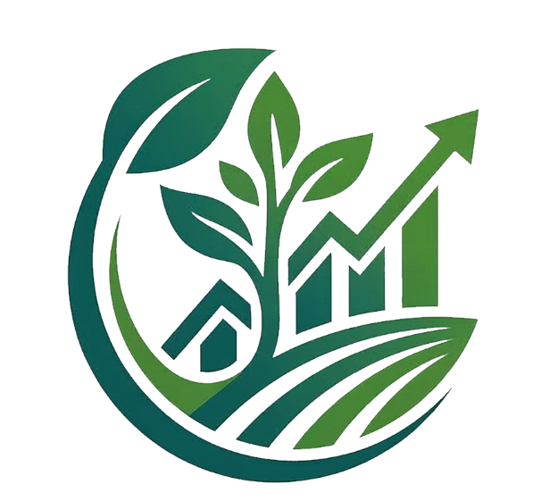

(Smart AgroConnect & Management System)
ABSTRACT

Agriculture is one of the most important sectors, but farmers still face many problems such as dependency on middlemen, low profits, lack of direct market access, financial difficulties during crop cultivation, and limited access to modern digital technologies. Traditional agricultural systems often create delays in communication, pricing, and crop management, making farming less profitable and inefficient for farmers. To solve these issues, the Farmogram system is developed as a smart web-based agricultural platform that connects farmers directly with buyers through a single digital system.
Farmogram is designed as a Progressive Website that supports farmers, buyers, and administrators through separate dashboards and role-based access. The platform allows farmers to manage crop details, monitor farming activities, receive weather updates, and sell crops directly to buyers without middlemen. Buyers can browse available crops, communicate with farmers, negotiate prices, and place orders easily through the platform. This direct interaction improves transparency and helps farmers receive better profits for their products.
The system also includes a crop pre-booking feature where buyers can reserve crops before harvest by paying an advance amount. This provides financial support to farmers during the cultivation stage and helps them manage farming expenses more effectively. In addition, the platform provides task scheduling and notification features that remind farmers about important farming activities such as watering, fertilizing, and harvesting.
Farmogram integrates AI-based assistance to help farmers identify crop diseases and receive farming suggestions. Farmers can upload crop images and use voice or text-based interaction to get treatment recommendations. The platform also supports crop insurance claims where farmers can digitally report crop damage and request financial assistance. Multi-language support is included to make the system easy to use for rural farmers.
The system is developed using HTML, CSS, JavaScript, PHP, and MySQL technologies. Overall, Farmogram demonstrates how digital technology can improve agricultural management, increase transparency, support farmers financially, and create a modern agricultural marketplace for efficient farming and trading.

TABLE OF CONTENTS

Chapter No | Title | Page No
 | ACKNOWLEDGEMENT
 | DECLARATION
 | ABSTRACT
1 | INTRODUCTION | 1
 | 1.1 Problem Statement | 2
 | 1.2 Objectives | 3
 | 1.3 Proposed System | 4
 | 1.4 Major Modules | 5 - 6
 | 1.5 Applications | 7
2 | HARDWARE AND SOFTWARE REQUIREMENTS | 8
 | 2.1 Hardware Configuration | 8
 | 2.2 Software Specification | 8
3 | SYSTEM DESIGN | 9
 | 3.1 Entity Relationship Diagram | 9
 | 3.2 Data Flow Diagram | 10 - 16
 | 3.3 Schema Diagram | 17
4 | TESTING AND IMPLEMENTATION | 18
 | 4.1 White Box Testing | 18
 | 4.2 Black Box Testing | 19
 | 4.3 Unit Testing | 20
 | 4.4 Integration Testing | 21
 | 4.5 System Testing | 22
 | 4.6 Acceptance Testing | 23
 | 4.7 Validation Testing | 24
5 | SCREENSHOTS | 25 - 41
 | CONCLUSION AND FUTURE SCOPE | 42 - 44
 | REFERENCES | 45

DECLARATION

I hereby declare that the entire work embodied in this project report titled “Farmogram”, submitted to Karnatak University, Dharwad, has been carried out by me at Himalaya BCA College, Ankola, under the supervision of Prof. Samyukta Naik, Head of the Department of B.C.A.

I am submitting this project report to Karnatak University, Dharwad, as a partial fulfilment of the requirements for the award of a degree in Bachelor of Computer Applications for the academic year 2025-26.

Prajwal L Gouda
(U02LT23S0007)

